

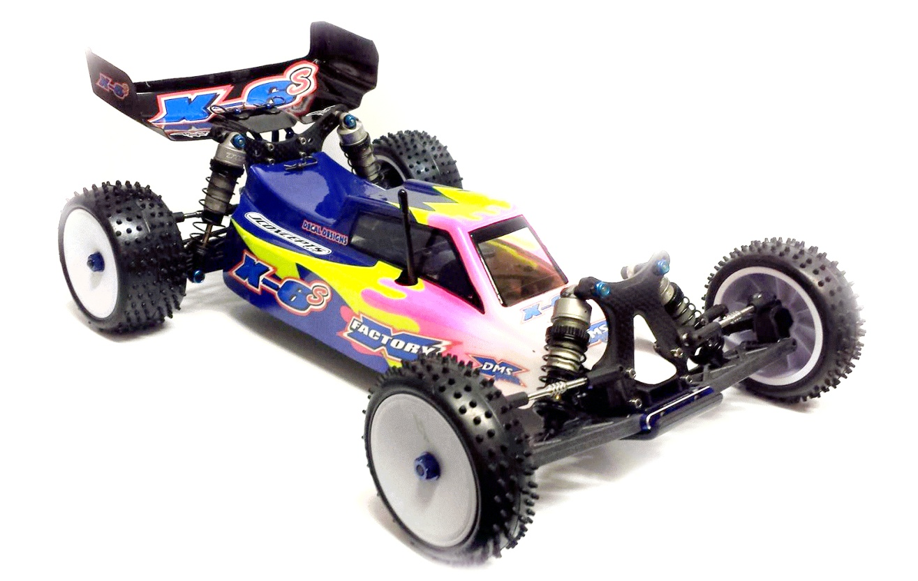

2wd Mid-Motor shaft drive conversion kit

Instruction Manual v1.1



 www.xfactoryrc.co.uk  www.facebook.com/XFactoryUK

