Arn0
B C
I O
Driver: _____________________ Date: __________
Track/Event: ________________________________
Track Conditions: ____________________________
Ride Height: __________________

Camber: _______º Toe: ________º

Ackerman: □Forward □Back
Total Weight: _______________

F/R Bias: ________ / _______
Tyres: Front_______________________ Rear________________________
Inserts: Front______________________ Rear________________________
ESC:____________ Servo:___________ Slipper: VTS / AVID / Double Disc / Flywheel Weight
Battery: ________________________ Motor: ______________________ Gearing: P_____ /S_____
Notes:
Centre:______
Shock Brand: ___________________
Spring: _________________________
Piston: _________________________
Oil: ____________________________
Shock Length: ____________
Limiter: Inside______ Outside______
Ride Height: __________________

Camber: _____ Anti Squat:______
Shock Brand: ___________________
Spring: _________________________
Piston: _________________________
Oil: ____________________________
Shock Length: ____________
Limiter: Inside______ Outside______
Anti Roll Bar:__________

Wing Mounts
__________

Wide Narrow

Wing Type
___________


Tyres and Electrics
Ballstud Washers
____________
Rear:________

Front:_____
Ballstud washers: ______ 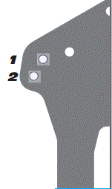

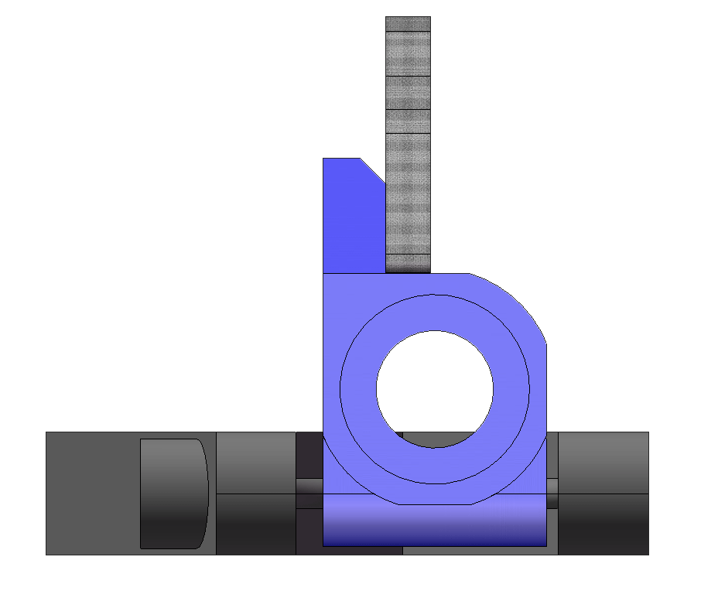
Hub Position:
□Back □Mid □Fwd
Hub Plate:
_________
D
C
A
B

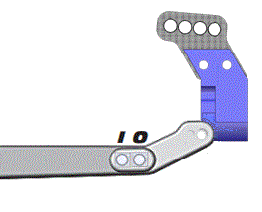
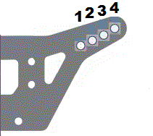
# Bumpsteer
Washers
________
Axles: □ Trailing □ Inline

Caster Block:
□20º □25º □30º
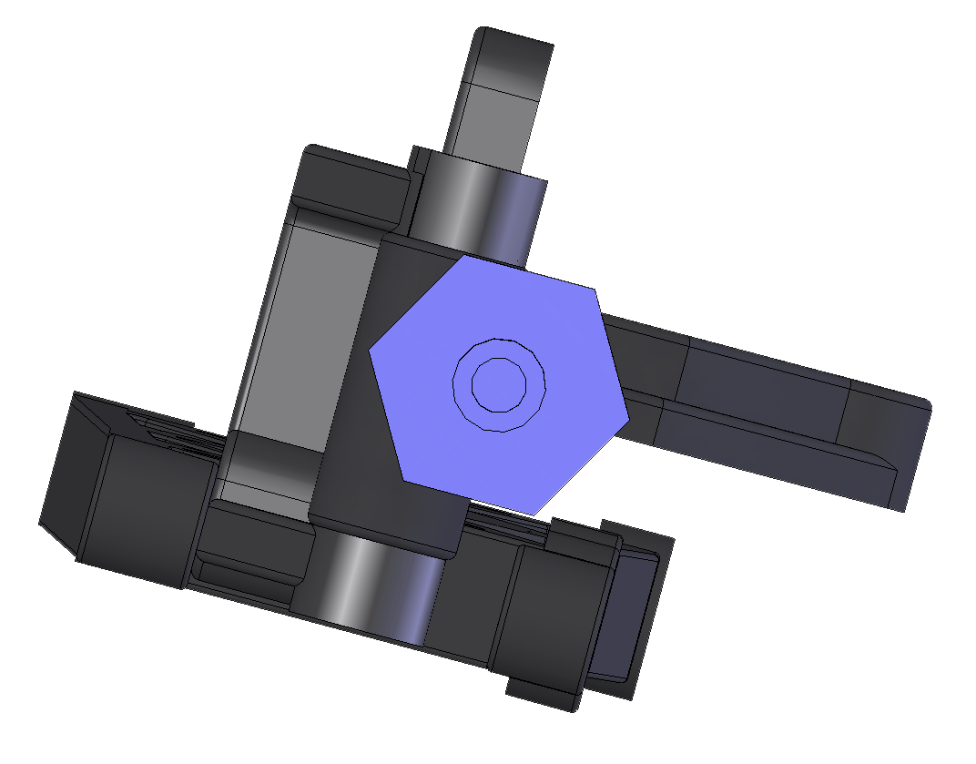
A
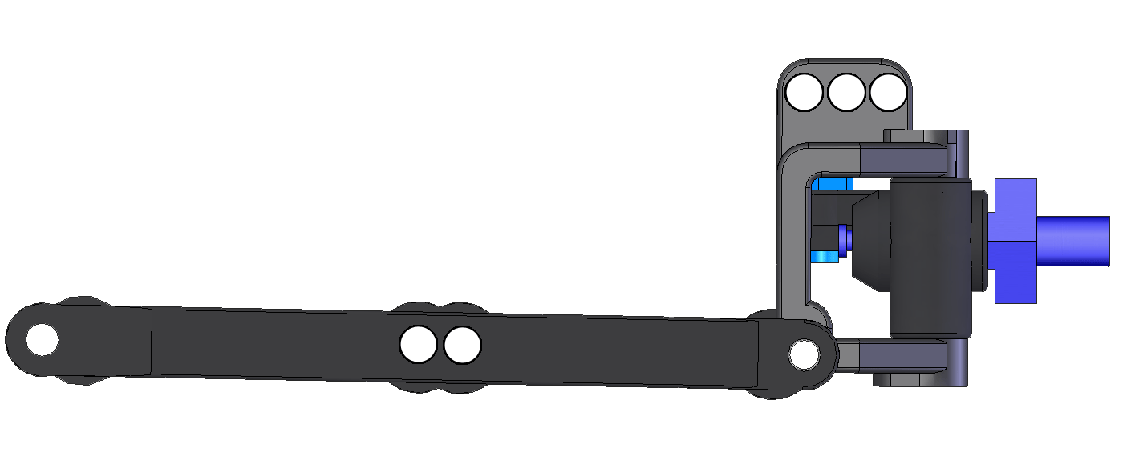
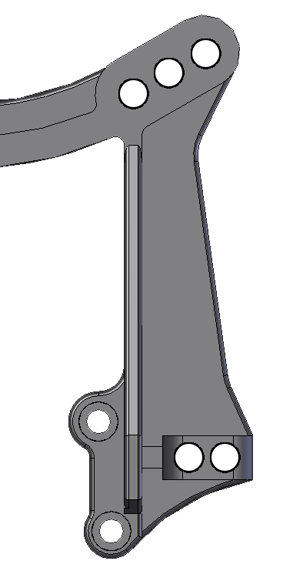
2
1
3
2
1
Rear Suspension
Weight
Front Suspension
Rear Shocks
Front Shocks
Position:
□Fwd □Back

