Anti Roll Bar: AE black

Wing Mounts
B44.2 kit

Wide Narrow

Wing Type
B44.2 Kit


Tyres and Electrics
Ballstud Washers
1.5mm
Centre:_____
Rear:________

Front:_____
Tyres: Front: yellow cut staggersRear Yellow mini spikes
Inserts: Front: None Rear: Ballistic Buggy White
ESC: Vampire SR1+ Servo: Spectrum Low profile Slipper: VTS

Battery: Vampire Shorty Motor: Vampire V2 6.0T Gearing: P22 /S Kit

Notes:Team SR front bumper, ball diff
Ballstud washers:2mm 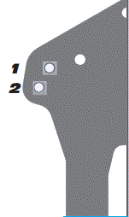
Ride Height: 16mm

Camber: -1º Anti Squat: Kit B44.2
A

Transmission Height: ___________

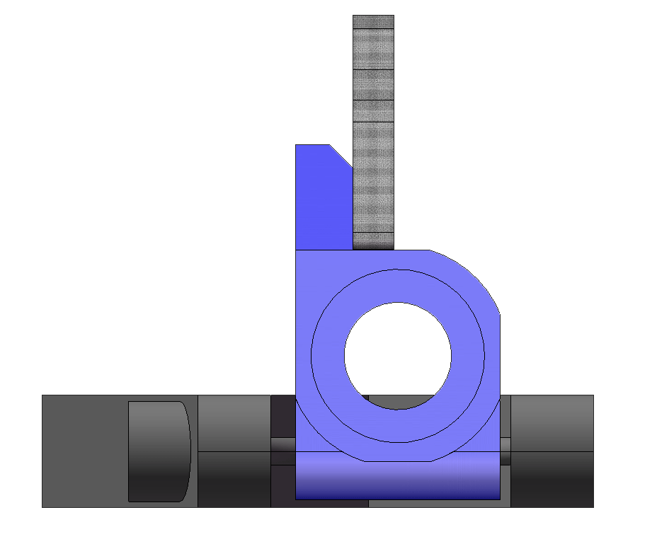
Hub Position:
□Back □Mid □Fwd
Hub Plate:
B44.2 kit
D
C
A
B

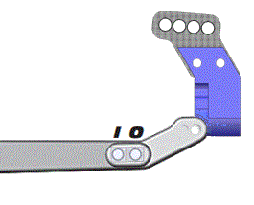

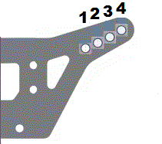
# Bumpsteer
Washers
2mm
Axles: □ Trailing □ Inline

Caster Block:
□20º □25º □30º

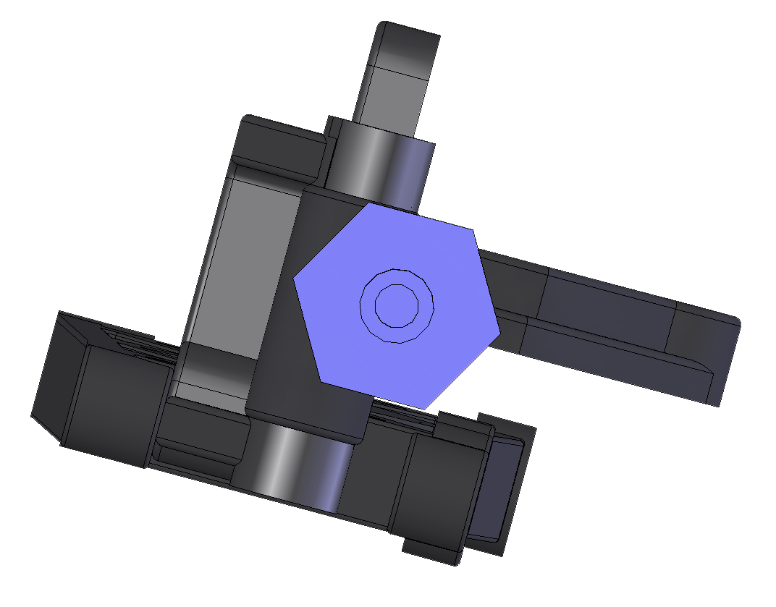
B
A
C
O
I
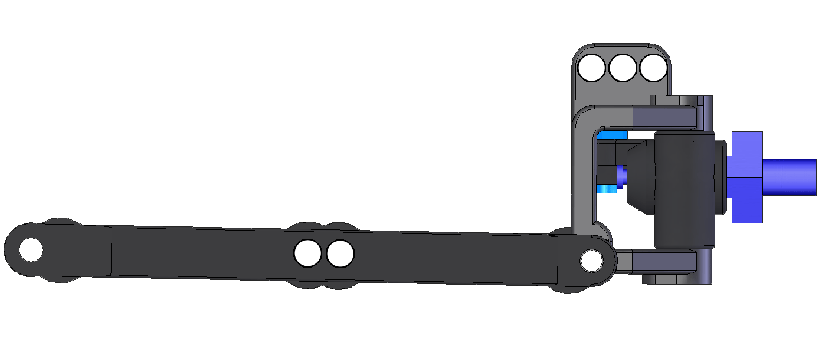
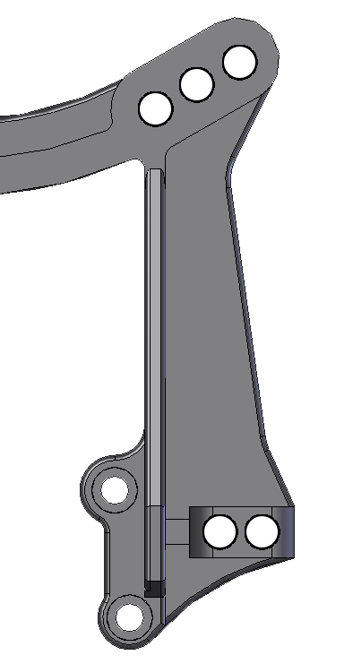
2
1
3
2
1
Driver: Kevin Hunt Date: 06/03/2014

Track/Event: Silverstone Winter series Rd6 SSilver________________________________ _________________________________
Rear Suspension
Type | Spring | Piston | Oil
AE BB | AE white | AE 1.7mm | TLR 37.5
TLR BB
Other

Shock Length: ____________

Limiters: Inside_____ Outside_____

Type | Spring | Piston | Oil
AE BB | TLR black | AE 1.6mm | TLR 45
TLR BB
Other

Shock Length: ____________

Limiters: Inside_____ Outside_____
Weight
Total Weight: 1493g

F/R Bias: _____ / _____
Front Suspension
Ride Height: 16mm

Camber: -1º Toe: 1º out

Ackerman: □Forward □Back
Rear Shocks
Front Shocks
Position:
□Fwd □Back

