Thankyou for purchasing the X6-S conversion kit from X-Factory UK....

The conversion is based on the front end geometry of the X-Factory X6 cubed 2wd mid motor buggy, but utilises the rear suspension and centre shaft drive transmission from the popular Associated B44.2 model. (B44 and B44.1 models can be used, but will require extra parts in order to complete your model).

Front End Please dis-assemble the front end from your X6 Cubed (if you are starting with a used one) and set aside as one assembled piece. The X6 Cubed manual can be found and downloaded online on the X-Factory website for this part of the build if required. Re-assemble to your X6-S in the same manner as the X6 Cubed.
Rear End Please follow the instruction manual of the B44.2 with regards to the assembly of the rear suspension assembly. Once more the manual can be found and downloaded online on the Associated website for this part of the build.
PLEASE NOTE - the differential on the X6-S is fitted in the "reverse" direction to the B44.2 instructions, in order to do so, please carefully remove the small pip inside the lower transmission case, this is essential to ensure your car does not go backwards!! Please see images below.
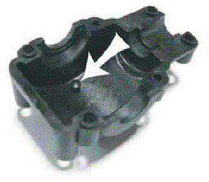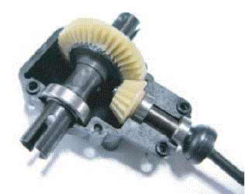
Centre Drive Assembly The centre bulkhead and motor mount assembly from the B44.2 are mounted the opposite way around on the X6-S (so the motor sits at the rear left as opposed to front right on the B44.2). The motor mount is at the rear and the centre bulkhead is at the front. The complete slipper assembly is inserted with the slipper nut facing rearwards, this also prevents the slipper from working loose in normal use. The slipper can be adjusted from either above or from below via the slot provided in the chassis. Please be sure that your slipper shaft assembly fits easily inbetween the centre bulkhead and motor mount, if it is tight, you may need to remove one of the top hat shims that AE recommend and replace with a shallower thickness spacer to allow for correct and proper slipper adjustment.

Main Chassis Assemble the alloy chassis posts to the chassis with 4-40 x 3/8" countersunk head screws, then place the lower front top deck pieces to the upper side of the top deck supports and chassis posts. Secure to the top deck supports with two 4-40 x 3/8" cap or button head screws. Place the chassis top deck spacers (DMS203) over the hole directly above the lower chassis posts. Attach the upper front bulkhead to the centre bulkhead assembly with two 4/40 x 3/8" countersunk screws, then place two 4/40" x 3/4" countersunk screws through the upper front top deck - passing through the top deck spacers and lower front top deck - then threading into the chassis posts below.

Final Assembly Assemble Carbon Fibre aerial mount to your chosen side (left or right), your receiver can mount either side or behind the servo if preferred. ESC is mounted behind the motor, we suggest routing your RX wire along the side of the chassis and placing the cable inside some heatshrink, this can then be attached to the chassis if required with CA glue for a neat and tidy install. Assemble the battery posts to the chassis in the provided holes, your "Shorty" type LIPO battery will sit snuggly inside the milled recess in the chassis, secure with the Carbon battery strap using either 4/40 x 1/2" countersunk screws or thumbscrews/nuts of your choice as you prefer. We strongly suggest thread-locking both the posts and screws to prevent them from coming loose in use. Trim body and wing to suit and attach via the rear B44 mount on the rear tower and for the front we suggest using either the 4/40 body mount screw from Associated (AS6929) mounted to the front top plate or velcro attached to the side of the carbon chassis stack that mounts the front end.

Rear Shock Tower If you are using the Level 2 conversion or have purchased the optional "Multi-Mount"(DMS202) you have the option of using a wide choice of wing mounts from various leading brands, this allows for either wide or narrow wing mounting options and high or low level wing settings. (See image below)

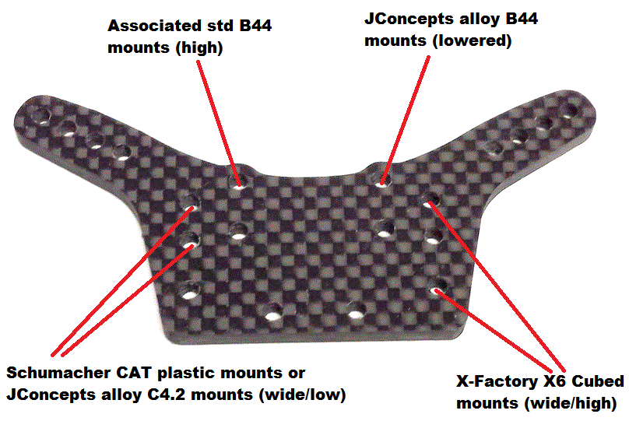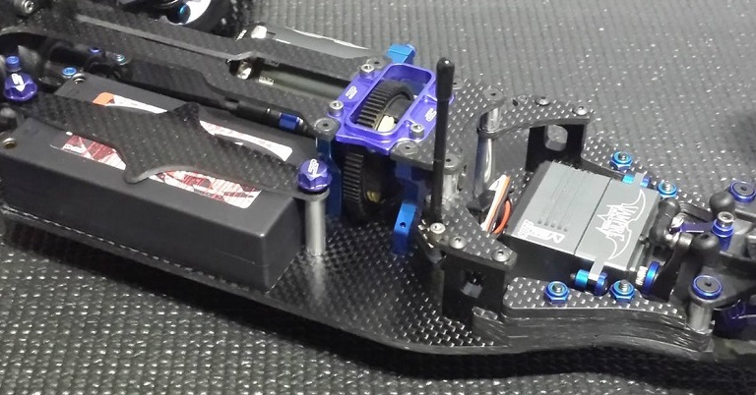
Final assembled centre section

