Centre: 40grs
Driver: Ed Kerry Date: 23/03/2014

Track/Event: High grip Carpet .
Anti Roll Bar: N/A

Wing Mounts
B44.2

Wide Narrow

Wing Type
X-Factory


Tyres and Electrics
Ballstud Washers
2.5mm
Rear:_______

Front: 45g
Tyres: Front: cut staggers Rear mini pin
Inserts: Front: Ballistic Buggy Rear: Ballistic Buggy
ESC: Vampire SR1+ Servo: Vampire Slipper: AVID

Battery: Vampire Motor: Vampire 6.5T Gearing: P23 /S 81

Notes: Durango Gear Diff with 3000w oil
Ballstud washers:3mm 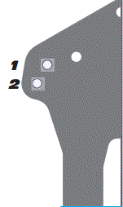
Ride Height: 19mm

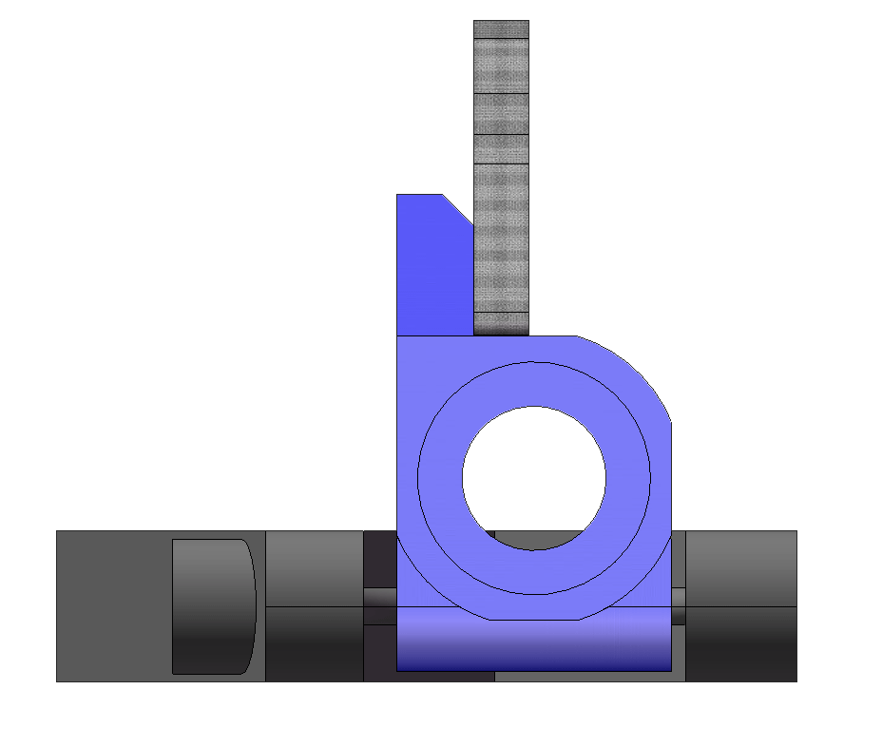
Hub Position:
□Back □Mid □Fwd
Hub Plate:
Avid
D
C
A
B

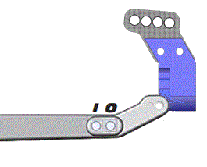

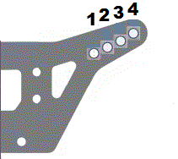
# Bumpsteer
Washers
2mm
Axles: □ Trailing □ Inline

Caster Block:
□20º □25º □30º

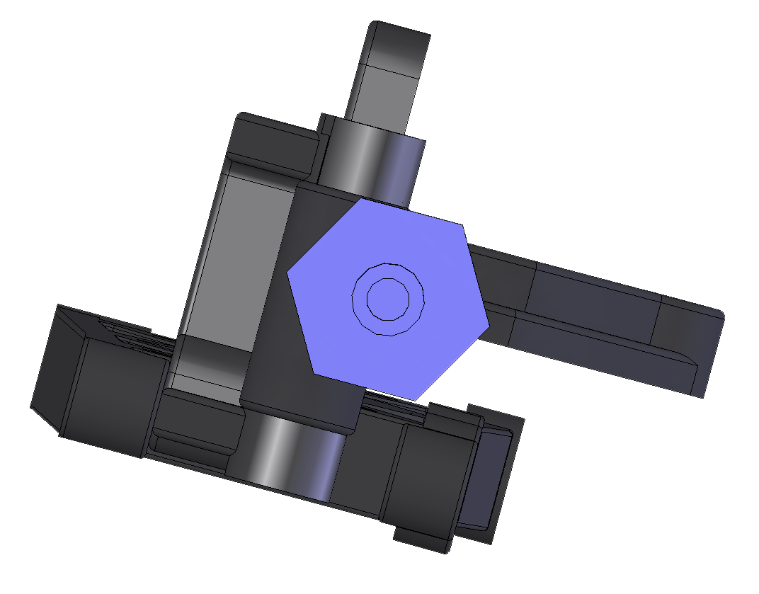
B
A
C
O
I
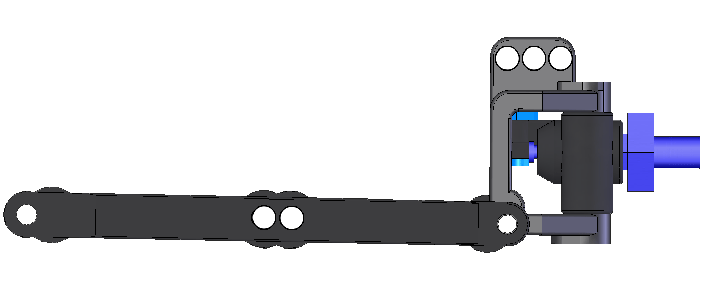
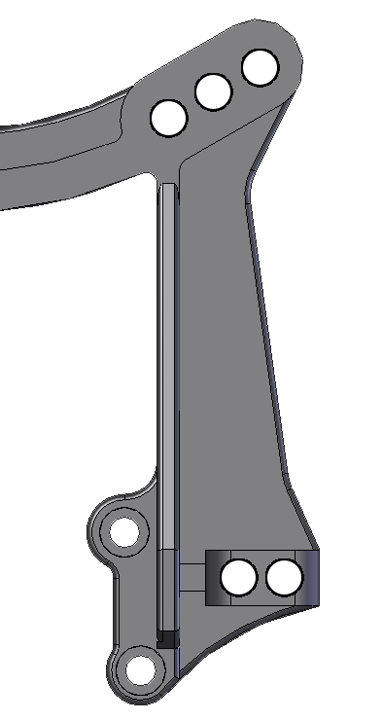
2
1
3
2
1
Rear Suspension
Type | Spring | Piston | Oil
AE BB | Losi Red | 1.7mm | 35
TLR BB
Other

Shock Length: ____________

Limiters: Inside 1 Outside 0

Type | Spring | Piston | Oil
AE BB | Losi Black | 1.6mm | 45
TLR BB
Other

Shock Length: ____________

Limiters: Inside 2 Outside 0 .
Weight
Total Weight: _________

F/R Bias: _____ / _____
Front Suspension
Ride Height: 18mm

Camber: -1º Toe: 1º out

Ackerman: □Forward □Back
Rear Shocks
Front Shocks
Position:
□Fwd □Back

