

BUILD TIPS AND SUPPLEMENTARY INSTRUCTIONS

Build Tips:
- This is the USA pro roller kit with many alloy upgrades included; make sure you check what upgrades you have before you start.
- Use thread lock where screws go into alloy.
- With ball studs in either the front or rear hubs be sure to use a tiny amount of thread lock and do not over tighten. Install studs using thread lock and let set up overnight, then remove and re install - leaves enough thread lock to hold and makes them really easy to remove.
(This helps should you break a ball stud as it gives you a fighting chance of using an ezy out to remove it. )
- The alloy front arm mount has a brass weight - it makes the camber mount block not sit flat as is, but you can carve some plastic out to make it fit. The 5 grams does help - so please install it.
- Run in the ball diff, a run in ball diff is usually around 1/4 to 1/8 from being snugged up.
- Run the slipper firm and loosen as you test in the first few laps, they can wear quickly if let to get too hot.

Supplementary Instructions:
Each step shown below replaces a step in the included manual, due to the inclusion of the Alloy hop ups in your kit.

Replaces Step 1:
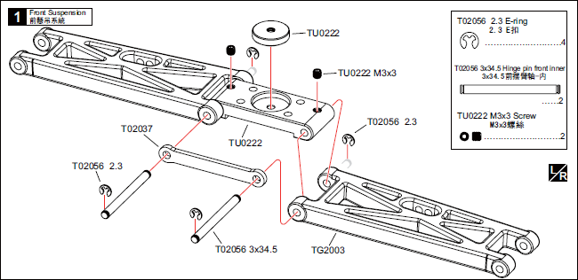
Replaces Step 2:
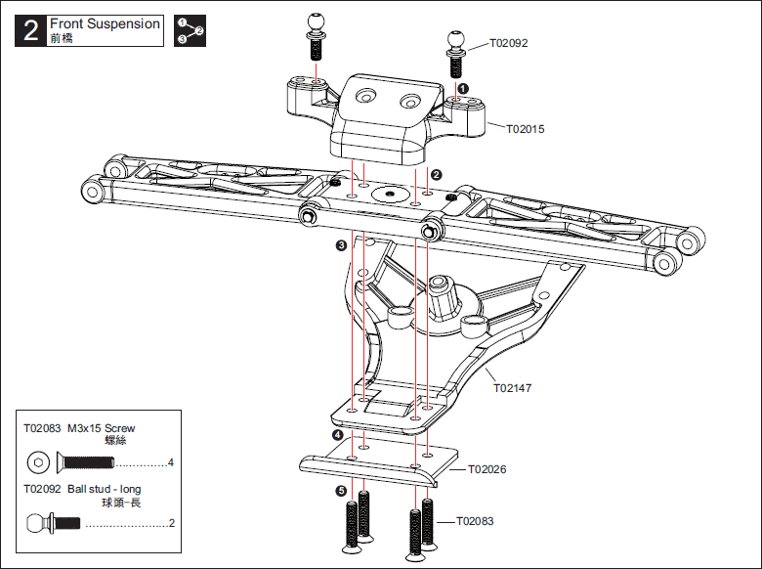
Replaces Step 5:
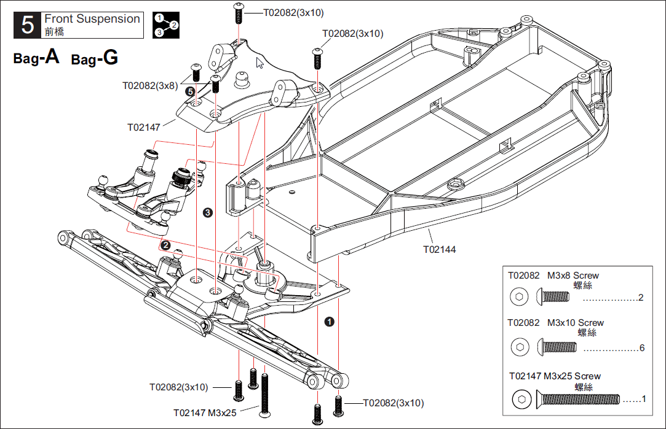
Replaces Step 6:
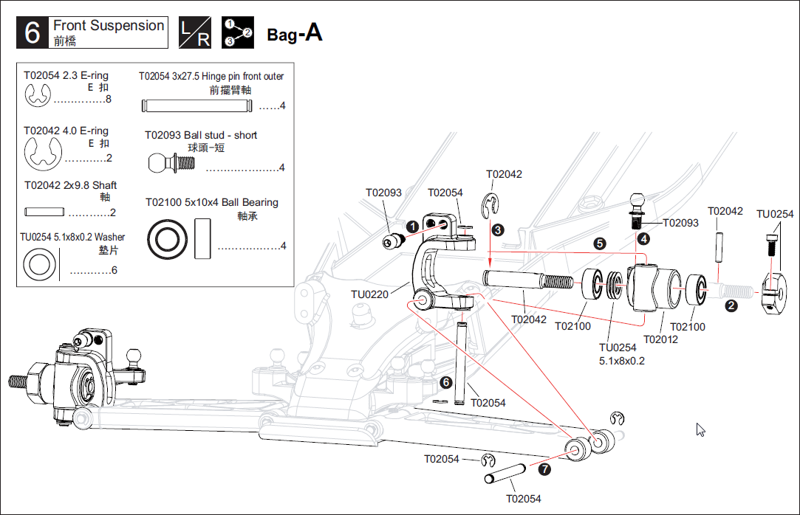

Replaces Step 9:
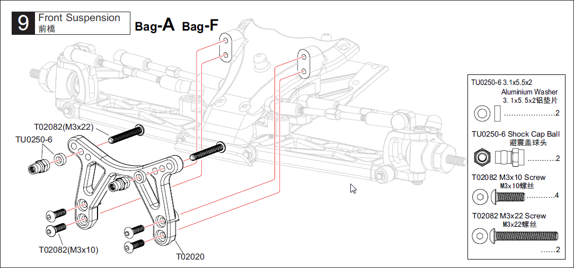
Replaces Step 14:
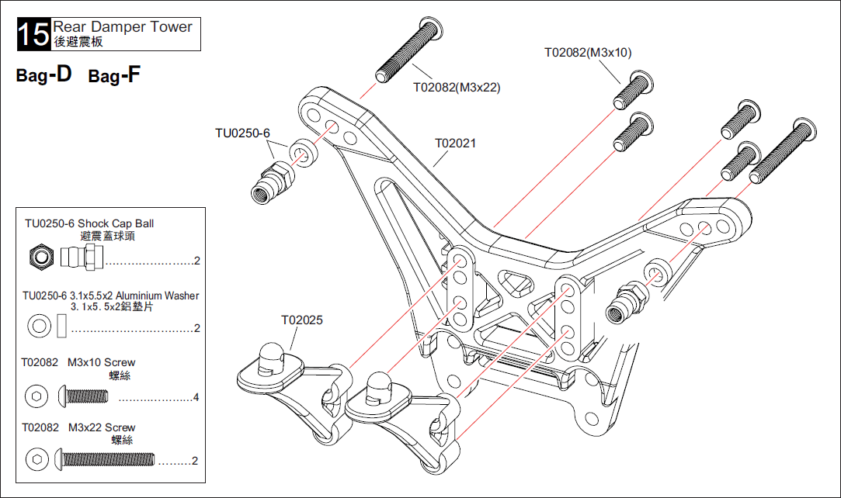

Replaces Steps 16 and 17:
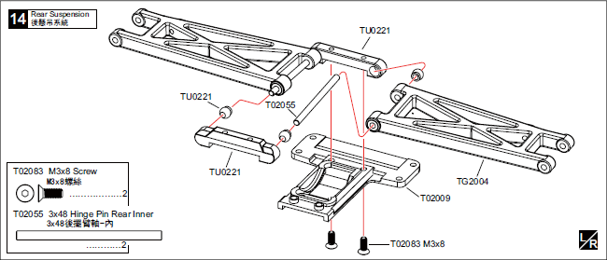
Replaces Step 21:
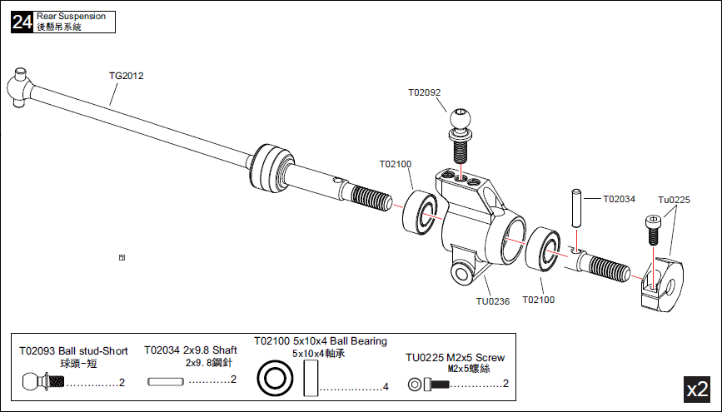

Replaces Steps 26, 27 and 28:
