
Driver: Surface: Grass/astro.
Track: Bury Grip level: Med .

Front:
Oil : 40 .
Spring losi blue .
Piston 56 .
Position: Tower: 1 2
Position Wishbone 1 2
Camber link Hub: 1 2 (Spacer 4 mm)
Camber link Tower Upper Lower 1 2
Anti Roll Bar none .
Bump steer washers 0 .

Rear:
Oil : 30 .
Spring aero red .
Piston 556 .
Position: Tower: 1 2 3
Position Wishbone 1 2 3
Camber link Hub: 1 2 3
Camber link Tower 1 2
Camber link Tower % from Bottom 25 %
Anti Roll Bar no .

Ride height Front DS level .
Ride height Rear DS level .
Camber Front -1 Rear -1 .
Toe Front 0 Rear 3~ .
Wheelbase 3mm in front of Rear Wishbone .
Anti Squat 2 shims .

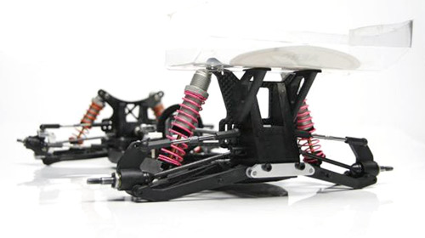
Front: Diff Oneway

ESC LRP .
Setting .
Motor Orion 5.5 .
Gearing 19/81 .
Rear Wing 7” V Jconcepts .
Notes/Comments.

The car felt very good, lots of steering and easy to drive, did have grip roll on the banking (Rear ride height too high) at times but it snowed before the next run so i never got to see if the change i made worked.
Tyres Front Yellow Mini spikes .
Tyres Rear .
Inserts Front .
Inserts Rear .
Wheel .
Please note that “1” refers to inside position of links etc

