
Driver: Surface: .
Track: Grip level: .

Front:
Oil : .
Spring .
Piston .
Position: Tower: 1 2
Position Wishbone 1 2
Camber link Hub: 1 2 (Spacer mm)
Camber link Tower Upper Lower 1 2
Anti Roll Bar .
Bump steer washers .

Rear:
Oil : .
Spring .
Piston .
Position: Tower: 1 2 3
Position Wishbone 1 2 3
Camber link Hub: 1 2 3
Camber link Tower 1 2
Camber link Tower % from Bottom %
Anti Roll Bar .

Ride height Front .
Ride height Rear .
Camber Front Rear .
Toe Front Rear .
Wheelbase .
Anti Squat .

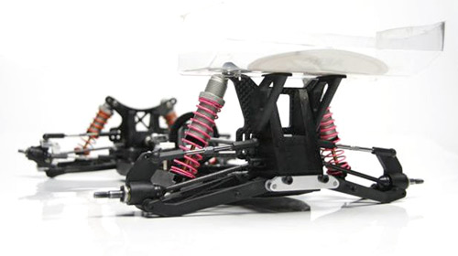
Front: Diff Oneway

ESC .
Setting .
Motor .
Gearing .
Rear Wing .
Notes/Comments.
Tyres Front .
Tyres Rear .
Inserts Front .
Inserts Rear .
Wheel .
Please note that “1” refers to inside position of links etc

