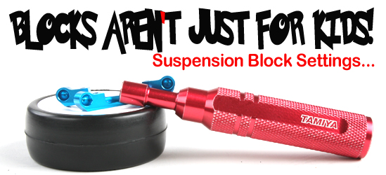
Suspension Block Settings By: Andrew Kuntze
When adjusting the setup of your kit to suit a particular track or driving condition, toe is an important tuning device. To make this adjustment easier, Tamiya utilizes suspension blocks of varying widths that can be mixed and matched to achieve the desired toe angle and track width on chassis such as the TRF416, TA05 and TB03.
Due to the variety of suspension blocks that are offered, it is possible to achieve the same toe settings with a variety of combinations of the suspension blocks. The table below shows all of the suspension block options, and the resulting toe settings that can be achieved where the "Outside" represents the suspension block furthest towards the front/rear of the chassis and the "Inside" represents the suspension block closest to the middle of the chassis.
When using a 1 degree rear hub carrier, the toe angle is decreased by 1 degree of toe-in. For example, if you are running -3.0 degrees of rear toe-in, by adding the 1 degree rear hub carriers, you will now have -4.0 degrees of toe-in.

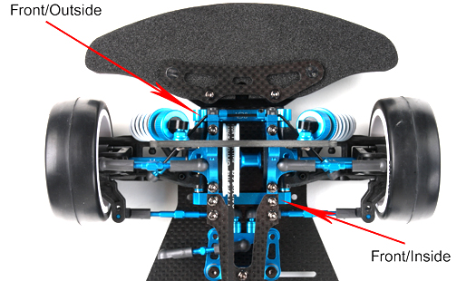

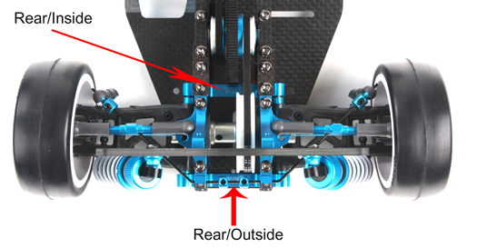

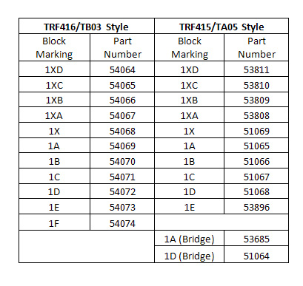
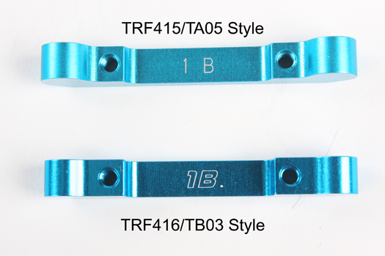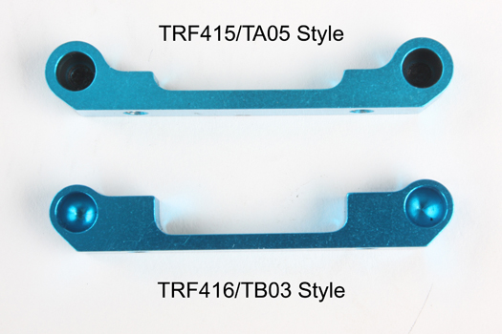
Note: Please note that due to the length of the drive shafts will not allow every combination of blocks to be used on the chassis. In addition, if a race or event mandates a 190mm width be used, some of the combinations will not be legal as they will exceed that limit.

TRF416 Suspension block chart by Ed Clark (www.thard.com)
Ok, this is a question thats asked a bit... what do the toe-blocks do?
Quite simply, they can change two settings on the car;
1) Toe angle (Rear toe-in and front arm-sweep)
2) Track width
So, how do you change these?
Well, each block has a 0.5° of angle step between each one, and they range, from widest to narrowest as
1F - TAM54074
1E - TAM54073 (TAM53896 for 415 version),
1D - TAM54072 (TAM51068)
1C - TAM54071 (TAM51067),
1B - TAM54070 (TAM51066),
1A - TAM54069 (TAM51065),
1X - TAM54068 (TAM51069),
1XA - TAM54067 (TAM53808),
1XB - TAM54066 (TAM53809),
1XC - TAM54065 (TAM53810),
1XD - TAM54064 (TAM53811).
So using a combination of 1XA/1E on the rear of the car (usually, people state the blocks as going from f->r on the car, so FF/FR, and RF/RR) will give 3° of rear toe-in. However, if you look on the chart above, you'll also notice that a combination of 1XD/1B will also give 3° of rear toe-in, so what the difference?
Quite simply, car track width (the overall width of the car). The 1XD/1B combination will be narrower than the 1XA/1E combination. This will result in quicker rotation in the corner, and slightly more overall grip on that end, however the car will be less stable as a result.
The same applies to the front end, where by using a combination of arm sweep and track width, the front end of the car can be fine tuned. A 1D/1D combination will result in a very stable front end (wide track, 0° of sweep), whilst using 1B/1A (arm sweep is toe-out for the front arms, hence the wider block at the front) will give a narrower front (more grip), with a bit of extra turn-in and mid-corner (due to the arm angle), at the expense of stability. It's a useful setting to play with, and not one many other cars can offer.
Hopefully this will help, oh and this goes for any car that uses the Tamiya suspension blocks (TA05, 415, Evo's)
Note #1: There are also two blocks from the 415 avaliable, TAM51064 D Bridge and TAM53685 A Bridge. These were designed for the front-rear position of the 415, with a raised centre section to clear the belt. These won't work in this positon on the 416, due to the offset belt... However they will still work in either the front-front or rear-rear positions on the car.
Note #2: This is another range of blocks avaliable as well, which were originally designed for use with the TB EVO IV. They are the same width as the 415/6 blocks, however mount the hinge pins 1mm higher in the car. This works in the same way as placing 1mm of shims under the block to raise the roll-centre. They can be easily spotted as they do not have the 1 infront of the letter, so are just marked, E (TAM53717), D (TAM53716), C (TAM53715), B (TAM53714), A (TAM53713), X (TAM53712). Be aware though, as most people just mark setup sheets without the 1, even though they are using the 415/6 blocks... myself included.
Note #3: I've edited the above list to include the recently released 416/TB03 blocks. Whilst the 415 are still fine for use, it's recomended to use the 416 versions in the front-rear position at the very least, simply as it makes flipping the block to clear the front belt easier, requiring just 3mm of spacers, rather than the 5mm (and slight modding work) of the 415 versions.

Tamiya 416 Suspension Block Charts
Overall Rear Toe
0° Hubs |  | Front Block
 |  | XD | XC |  | XB | XA | X | A | B | C | D | E | F
Rear Block | XD | 0.0° | -0.5° |  | -1.0° | -1.5° | -2.0° | -2.5° | -3.0° | -3.5° | -4.0° | -4.5° | -5.0°
Rear Block | XC | 0.5° | 0.0° |  | -0.5° | -1.0° | -1.5° | -2.0° | -2.5° | -3.0° | -3.5° | -4.0° | -4.5°
Rear Block | XB | 1.0° | 0.5° |  | 0.0° | -0.5° | -1.0° | -1.5° | -2.0° | -2.5° | -3.0° | -3.5° | -4.0°
Rear Block | XA | 1.5° | 1.0° |  | 0.5° | 0.0° | -0.5° | -1.0° | -1.5° | -2.0° | -2.5° | -3.0° | -3.5°
Rear Block | X | 2.0° | 1.5° |  | 1.0° | 0.5° | 0.0° | -0.5° | -1.0° | -1.5° | -2.0° | -2.5° | -3.0°
Rear Block | A | 2.5° | 2.0° |  | 1.5° | 1.0° | 0.5° | 0.0° | -0.5° | -1.0° | -1.5° | -2.0° | -2.5°
Rear Block | B | 3.0° | 2.5° |  | 2.0° | 1.5° | 1.0° | 0.5° | 0.0° | -0.5° | -1.0° | -1.5° | -2.0°
Rear Block | C | 3.5° | 3.0° |  | 2.5° | 2.0° | 1.5° | 1.0° | 0.5° | 0.0° | -0.5° | -1.0° | -1.5°
Rear Block | D | 4.0° | 3.5° |  | 3.0° | 2.5° | 2.0° | 1.5° | 1.0° | 0.5° | 0.0° | -0.5° | -1.0°
Rear Block | E | 4.5° | 4.0° |  | 3.5° | 3.0° | 2.5° | 2.0° | 1.5° | 1.0° | 0.5° | 0.0° | -0.5°
Rear Block | F | 5.0° | 4.5° |  | 4.0° | 3.5° | 3.0° | 2.5° | 2.0° | 1.5° | 1.0° | 0.5° | 0.0°
Front Arm Sweep
 |  | Front Block
 |  | XD | XC |  | XB | XA | X | A | B | C | D | E | F
Rear Block | XD | 0.0° | -0.5° |  | -1.0° | -1.5° | -2.0° | -2.5° | -3.0° | -3.5° | -4.0° | -4.5° | -5.0°
Rear Block | XC | 0.5° | 0.0° |  | -0.5° | -1.0° | -1.5° | -2.0° | -2.5° | -3.0° | -3.5° | -4.0° | -4.5°
Rear Block | XB | 1.0° | 0.5° |  | 0.0° | -0.5° | -1.0° | -1.5° | -2.0° | -2.5° | -3.0° | -3.5° | -4.0°
Rear Block | XA | 1.5° | 1.0° |  | 0.5° | 0.0° | -0.5° | -1.0° | -1.5° | -2.0° | -2.5° | -3.0° | -3.5°
Rear Block | X | 2.0° | 1.5° |  | 1.0° | 0.5° | 0.0° | -0.5° | -1.0° | -1.5° | -2.0° | -2.5° | -3.0°
Rear Block | A | 2.5° | 2.0° |  | 1.5° | 1.0° | 0.5° | 0.0° | -0.5° | -1.0° | -1.5° | -2.0° | -2.5°
Rear Block | B | 3.0° | 2.5° |  | 2.0° | 1.5° | 1.0° | 0.5° | 0.0° | -0.5° | -1.0° | -1.5° | -2.0°
Rear Block | C | 3.5° | 3.0° |  | 2.5° | 2.0° | 1.5° | 1.0° | 0.5° | 0.0° | -0.5° | -1.0° | -1.5°
Rear Block | D | 4.0° | 3.5° |  | 3.0° | 2.5° | 2.0° | 1.5° | 1.0° | 0.5° | 0.0° | -0.5° | -1.0°
Rear Block | E | 4.5° | 4.0° |  | 3.5° | 3.0° | 2.5° | 2.0° | 1.5° | 1.0° | 0.5° | 0.0° | -0.5°
Rear Block | F | 5.0° | 4.5° |  | 4.0° | 3.5° | 3.0° | 2.5° | 2.0° | 1.5° | 1.0° | 0.5° | 0.0°
Key | Positive numbers = Toe / arm sweep in |  |  |  |  |  |  | Negative numbers = Toe / arm sweep out
Part number designations
 | TRF416 style |  |  |  |  | TRF415 style |  |  |  | Evo4 style
 | Outlined Italic lettering |  |  |  |  | Italic lettering |  |  |  | Italic lettering + 1mm taller
 | Block Marking |  |  | Part Number |  | Block Marking |  | Part Number |  | Block Marking |  | Part Number
XD | 1XD |  |  | TAM54064 |  | 1XD |  | TAM53811
XC | 1XC |  |  | TAM54065 |  | 1XC |  | TAM53810
XB | 1XB |  |  | TAM54066 |  | 1XB |  | TAM53809
XA | 1XA |  |  | TAM54067 |  | 1XA |  | TAM53808
X | 1X |  |  | TAM54068 |  | 1X |  | TAM51069 |  | X |  | TAM53712
A | 1A |  |  | TAM54069 |  | 1A |  | TAM51065 |  | A |  | TAM53713
B | 1B |  |  | TAM54070 |  | 1B |  | TAM51066 |  | B |  | TAM53714
C | 1C |  |  | TAM54071 |  | 1C |  | TAM51067 |  | C |  | TAM53715
D | 1D |  |  | TAM54072 |  | 1D |  | TAM51068 |  | D |  | TAM53716
E | 1E |  |  | TAM54073 |  | 1E |  | TAM53896 |  | E |  | TAM53717
F | 1F |  |  | TAM54074
A |  |  |  |  |  | 1A (Bridge) |  | TAM53685
D |  |  |  |  |  | 1D (Bridge) |  | TAM51064
Kit Settings
 |  |  | Front |  |  | Rear |  |  |  | Front |  | Rear
 |  |  | Front |  | Rear | Front | Rear |  |  | Front | Rear | Front | Rear
TRF 41X's |  |  |  |  |  |  |  | TA05's
TRF415** |  |  | 1D |  | 1D (b) | 1C | 1D | TA05 |  | 1A (p) | 1A (p) | 1A (p) | 1A (p)
TRF415 MS |  |  | 1A |  | 1A (b) | 1A | 1C | TA05-R |  | 1A | 1A (b) | 1A | 1D
TRF415 MSX |  |  | 1B |  | 1XB | 1XB | 1D | TA05 MS |  | 1B | 1A (b) | 1XB | 1D
TRF415 MSX MRE |  |  | 1B |  | 1A (b) | 1XB | 1D | TA05 IFS |  | 1A (p) | 1A (p) | 1A (p) | 1A (p)
TRF415 MSXX |  |  | 1B |  | 1A (b) | 1XB | 1D | TA05 IFS-R |  | 1B | 1A (b) | 1XB | 1D
TRF415 MSXX MRE07 |  |  | 1B |  | 1A (b) | 1XB | 1D | TB's
TRF416 |  |  | 1B |  | 1A | 1XB | 1D | TB02 |  | A (p) | A (p) | A (p) | A (p)
TRF416WE |  |  | 1C |  | 1C | 1XA | 1F | TB02-R |  | A (p) | A (p) | A (p) | A (p)
TB EVO's |  |  |  |  |  |  |  | TB03 |  | 1A (p) | 1A (p) | 1XA (p) | 1D (p)
TB Evo3 |  |  | A |  | A | A | C
TB Evo4 |  |  | A |  | A | A | E |  | Key | (p) | Plastic kit block
TB Evo4 MS |  |  | 1A |  | 1A | 1XB | 1D |  | Key | (b) | Bridge block
TB Evo5 |  |  | 1D |  | 1D | 1XA | 1E
TB Evo5 MS |  |  | 1D |  | 1D | 1XA | 1E

